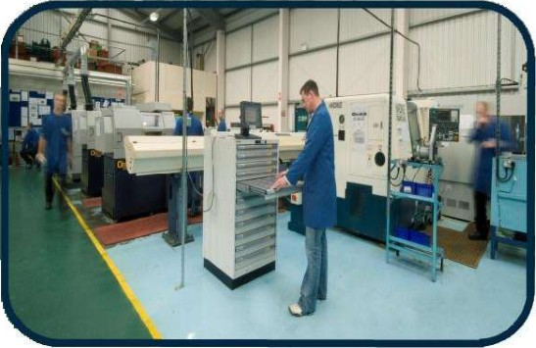DP Engineering Ltd recognise and believe in the importance of safeguarding natural resources and the environment. We are committed to continually improving our environmental performance in all products and services of our business from purchasing and manufacture through to delivery and disposal of waste. In accordance with our commitment to the principles of BS EN ISO 14001 we will:

* 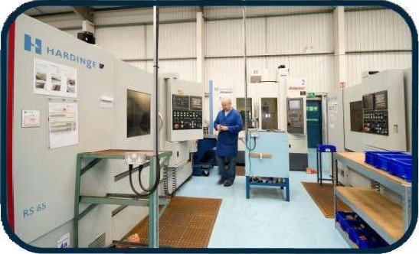Control and manage energy consumption to conserve natural resources.
* Minimise the generation of waste and use of packaging materials through our Lean activities.
* Prevent the pollution and contamination of air, land and water through regular monitoring of our processes.
* 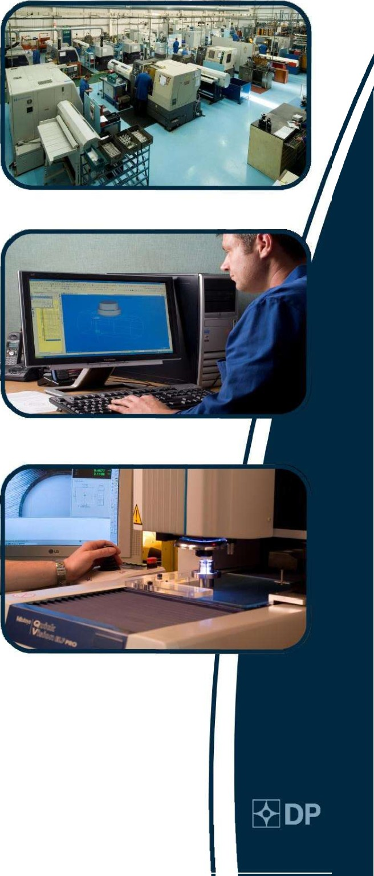Operate in compliance with European, national and local environmental regulations, and other requirements to which the organisation subscribes.
* Respond to the environmental concerns of our Customers, employees and the communities in which we operate.
* Train and involve all our employees and anyone working on our behalf in understanding the significant environmental impacts of their activities.
* Support and influence our Suppliers to improve their own environmental performance.
* Maintain a programme of continuous improvement of all activities directly affecting the environment by regular review and monitoring.
* Set achievable environmental targets and objectives to improve our business performance.

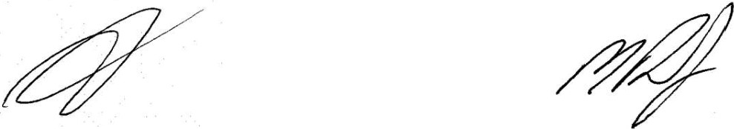

Richard Trevail Mark Darby

Managing Director Quality Manager

Dated 31st March 2017

Rev1

Registered Office: Lowin House, Tregolls Road, Truro, Cornwall. TRI 2NA. Certificate of Incorporation No: 4378564